1. Collect the 200 random samples and check the test of normality. Define statistically the samples are normally distributed or not.
2. Collect the 20 random samples and check the test of normality. Define statistically the samples are normally distributed or not.
3. A professor wants to know if her introductory statistics class has a good grasp of basic math. Six students are chosen at random from the class and given a math proficiency test. The professor wants the class to be able to score above 70 on the test. The six students get scores of 62, 92, 75, 68, 83, and 95. Can the professor have 90 percent confidence that the mean score for the class on the test would be **above** 70? [T-Critical Value- 1.71, One Tail, Reject]
4. A Little League baseball coach wants to know if his team is representative of other teams in scoring runs. Nationally, the average number of runs scored by a Little League team in a game is 5.7. He chooses five games at random in which his team scored 5 , 9, 4, 11, and 8 runs. Is it **likely that** his team's scores could have come from the national distribution? Assume an alpha level of 0.05. [T-Critical Value- 1.32, Two Tail, Accept]
5. Perform Two Sample T-Test.
6. Create data set by entering the instances from user. Create two samples of ML subject Marks and Attendance Marks of 25 students. After creating stud.csv upload in python and perform Two Sample [Independent] Test.
7. Forty-four sixth graders were randomly selected from a school district. Then, they were divided into 22 matched pairs, each pair having equal IQ's. One member of each pair was randomly selected to receive special training. Then, all of the students were given an IQ test. Test results are summarized below.



1. 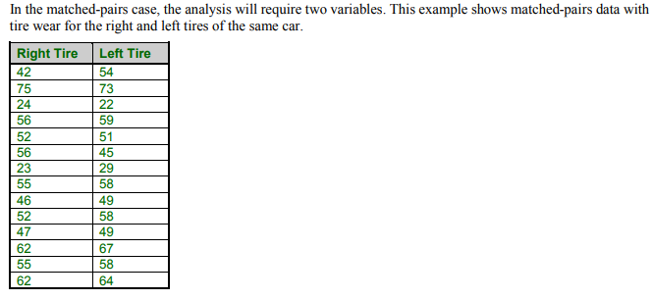

Perform paired t test.

1. Let us assume a population of students in a school who appeared for a class test. The mean score in the test is 75 and the standard deviation is 15. Determine the z-test score of David who scored 90 in the test.
2. Let us take the example of 30 students who were selected as a part of a sample team to be surveyed to see how many pencils were being used in a week. Determine the z-test score for the 3rd student of based on the given responses: 3, 2, 5, 6, 4, 7, 4, 3, 3, 8, 3, 1, 3, 6, 5, 2, 4, 3, 6, 4, 5, 2, 2, 4, 4, 2, 8, 3, 6, 7.
3. The amount of a certain trace element in blood is known to vary with a standard deviation of 14.1 ppm (parts per million) for male blood donors and 9.5 ppm for female donors. Random samples of 75 male and 50 female donors yield concentration means of 28 and 33 ppm, respectively. What is the likelihood that the population means of concentrations of the element are the same for men and women?
4. The following data is given:

|  |  |  |  |
| --- | --- | --- | --- |
| Types of Animals | Number of animals | Average Domestic animals | Standard Deviation |
| Dogs | 5 | 12 | 2 |
| Cats | 5 | 16 | 1 |
| Hamsters | 5 | 20 | 4 |

Calculate the Anova Coefficient.

1. For interpretation purposes, we refer to the differences in weights as weight losses and the observed weight losses are shown below.

|  |  |  |  |
| --- | --- | --- | --- |
| **Low Calorie** | **Low Fat** | **Low Carbohydrate** | **Control** |
| 8 | 2 | 3 | 2 |
| 9 | 4 | 5 | 2 |
| 6 | 3 | 4 | -1 |
| 7 | 5 | 2 | 0 |
| 3 | 1 | 3 | 3 |

Is there a statistically significant difference in the mean weight loss among the four diets?  We will run the ANOVA using the five-step approach.

1. 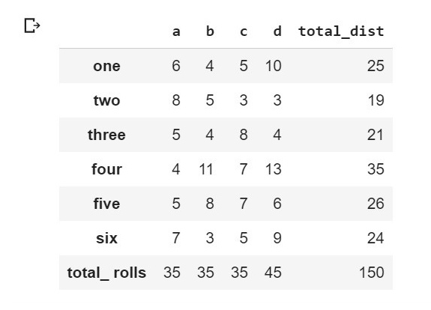Perform Chi-square test.

1. Perform sales analytics using MA, ES, DES,TES and ARIMA on following data.

|  |  |
| --- | --- |
| Year | Sales ($M) |
| 2003 | 4 |
| 2004 | 6 |
| 2005 | 5 |
| 2006 | 8 |
| 2007 | 9 |
| 2008 | 5 |
| 2009 | 4 |
| 2010 | 3 |
| 2011 | 7 |
| 2012 | 8 |